Merry Christmas and welcome to the "Ferguson Family 2nd annual Christmas Letter". As you could surmise from the lateness of this letter (so late that we don't have time to mail it, so email is the best we can do) it has been a VERY busy year.

When we last left you, I was telling you about my job, Samantha's study, and our time with the Coogee Surf club. Well in the year that has past, Samantha has become too busy to study, My job has spiralled out of control, and we have left Coogee.

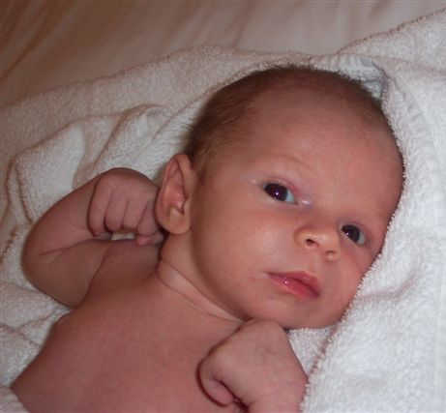
I suppose I have to start with the biggest news first. The Ferguson family Christmas letter is now coming to you from not just 2 Ferguson’s but 3. In November of this year, Samantha and I grew our family with the addition of Shayman James Ferguson. He was born on November 4th, at a modest 3.21Kgs. As I write this letter, he is 6 weeks old and does not seem to be as excited about Christmas as his dad is. I guess that will come in the years to come. I could probably do 20 pages on him alone (not to mention 1000 photos) but instead of boring everyone with typical baby talk, I will point you all to Shayman’s website. We are attempting to keep the site fairly up to date, and will be posting lots of photos there. The site can be found at http://www.whereintheworldarethefergusons.com/

Due to the arrival of Shayman, Samantha has had to put her study on hold. When her course finished earlier this year, she already knew she was pregnant, so the decision to carry on was already made for her. To make things better, she got approached by IDS to join me, working from home, and helping out with the monthly invoicing.

IDS also caused another major change to our lives this year. As the company is growing, they approached me to broaden my area to include Asia and Middle East. This was attempted from our base in Coogee for a couple of months, but quickly became evident that it would not be feasible. Thereby presenting to us one of the biggest opportunities of our lives, a chance to live in Asia.
Around May of this year, we packed up for a round the world business trip that would see us finishing in KL. After 8 weeks in Calgary to get some work done there, we came back to Kuala Lumpur to settle down. The timing of this was perfect as it put us here for the last 3 months of the pregnancy, which was just enough time to get settled and ready for Shayman’s arrival.

Rather than bore you all with constant drivel about work and Baby news, I should also pad this out with some talk about our travels. Unfortunately I have not had any vacation time from work this year, and have been constantly on the move (Ahh, poor Tim I hear you say, but wait, there is good news with this). Since I have constantly been working and travelling, I have managed to bring Samantha out on a couple of the trips and made the most of bad situations. Here are the highlights:

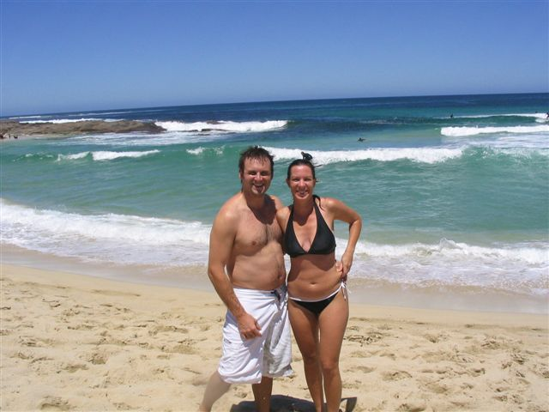
In January of this year Samantha was invited with me on a trip to KL to see the company. To start this trip off, we went via Perth and spent a glorious weekend in the Margaret River. This is one of Australia’s wine regions, and is some of the most beautiful beaches and wineries we have ever had the fortune of seeing. On the trip we met up with some old friends from our London days, who seem to be mirroring us in life experiences. Paul and Jane Beauglehole had a baby Girl about 1 month prior to us, so I guess this trip marked the last night out we will have with Paul and Jane where Children is not the top focus of conversation.

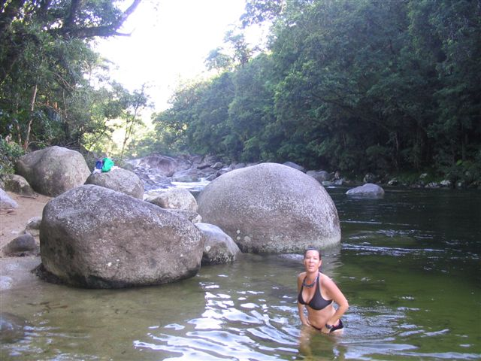
In April of this year I again found myself needing a break and on a business trip to Cairns. Samantha flew up to meet me, and we took a long weekend where we rented a campervan and travelled north through the rainforest and play tourist. There where too many great things to do up there to mention them all, I will just say if you ever get a chance to see the areas around Cairns, make sure you do. We did not even make it out to the Great Barrier Reef, so another trip up there is definitely in the cards. The highlight of the whole weekend was an early morning swim at Mossman Gorge. We got there early enough to have it to ourselves and found it hard to leave. This photo is of Samantha in the gorge, and even though she looks so great, was already 2 months pregnant in the shot.

In May we had a quick stopover in Lennox head before leaving for Canada. This again was a fantastic trip and a great opportunity for us to catch up with some friends. We spent 6 weeks in our companies’ apartment in Calgary. Although there was a lot of work to be done, we managed to get away most weekends and had a great time visiting Banff, Cranbrook, and Grande Prairie. The timing was pretty good as we where able to make it to an old school friends wedding. Dennise and Terry Dupley got married just outside of Cranbrook and both Samantha and I felt very privileged to be a part of it. Congratulations Dennise and Terry.

Although timing for this trip was pretty good, it was not perfect. We made a trip up to Grande Prairie to see Dave, Nicole, and Kaylee (Tim’s sister’s family) and had a fantastic catch up. Unfortunately we where 1 month early as our Niece, Alexis Anne Pitcher was born 1 month after we left. Disappointing, but we will catch her on our next trip.

This picture here is of Samantha on our trip to Banff. She is only slightly starting to show.

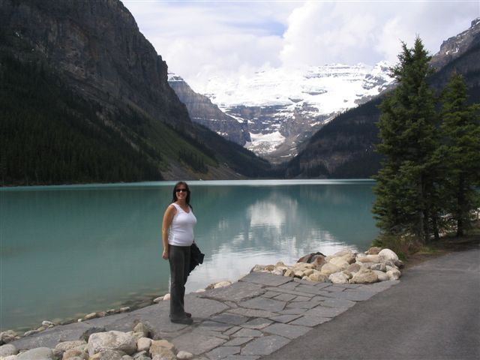

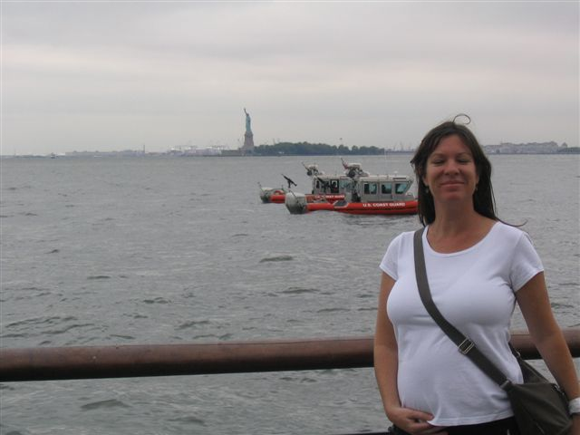
After our time in Canada, we where scheduled to come back to Asia, however, it was the long way around we had to go as I was due for business meetings in England. To make the best of the situation, we scheduled a trip to New York in on our way by. Our 4 days in New York was not even close to enough time. Another trip to New York will not be far off. We happened to arrive on the same day as the London Bombings, so security was a little bit stricter than usual, and as is the American style, seemed to be more intimidating than re-assuring. Here is a great snap of Samantha with the statue of liberty in the background.
So, as you can see, this year has been very busy and ended as perfectly as we could have hoped. We are now happily living in Kuala Lumpur and anxious for the day when Shayman is old enough to see some sites. We are optimistic that next years Christmas letter will have just as much news to report on, but this time it should be more “Asia-centric”. Hope all is well with everyone look forward to hearing from you all soon.

Merry Christmas and wishing you all the best in the New Year!

Samantha, Tim and Shayman Ferguson

