Merry Christmas!

Well, it’s rapidly approaching the end of the year, which prompts the crafting of the ‘Ferguson Family 1st annual Christmas Letter’. 2004 has been a very exciting and productive year in the Ferguson household. We have gone from backpacking bums, to Sydney DINK’s (Double income, No Kids).

The start of 2004 saw the 2 of us with backpacks on our backs, and nothing to our names as we made our way through Morocco, Egypt, India, Thailand, Malaysia and Singapore. All of this was a quest to get from Dublin to Sydney. Although we took a little longer than most to make the journey, it was eventually completed, and a lifetime of memories where created during the quest. I could write 20 pages on that trip alone, but as the year has been so good to us, I will try to move on quickly so as not to end up with a “Christmas Novel” rather than the intended “Christmas Letter”.

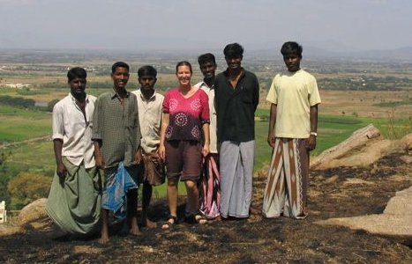

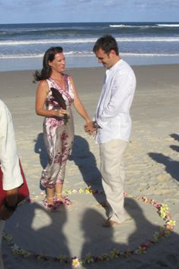
Upon our return to Australia, we decided a month in an Australian resort town was necessary to unwind from our “Holiday”. We spent the month in Lennox head with Samantha’s parents, John and Liz Griffiths. It was a fantastic month as Tim’s parents, Sister and young niece descended on the sleepy town of Lennox Head as well. The highlight of the month was definitely the 28th of February, when 30 very close friends and family all congregated on the beautiful 7 mile beach to witness the official beginning of the Ferguson family. I had pushed for the date to be the 29th of February, but that got vetoed very quickly. Samantha was the perfect bride in a sexy summer dress and the day went far quicker than it should have. I am a bit biased, but I can honestly say it is the best wedding I have ever attended.

In March, we set out to settle down in Sydney and hopefully settle into somewhat of a regular pattern again. At the end of our trip, whilst in Malaysia, I had signed a contract with IDS Datanet (www.idsdatanet.com web based reporting software for the oil patch) to be the Australian based engineer for the company. This took a lot of the stress out of the unemployment situation most backpackers face at the end of trips. We moved back down to Sydney and settled into a great apartment in Coogee. Living once again on the gorgeous Australian coast, we settled very quickly into the urban lifestyle.

Working for IDS has proved to be both challenging and exciting. I could not have tailor made a better job for myself. I am the only one in Australia (Which by default makes me the Australian Manager), which equates to a very broad job description. I have been splitting my time up between programming, Marketing, IT Support, Hardware engineer, new product development, Testing, and a lot of travel. I am extremely happy with the job and the company and fiercely optimistic about both the future of the company, as well as my continued enjoyment in such an exciting and varied role within this company. I never would have thought I would end up back in the oil patch after my stint up in Grande Prairie all those years ago.

Samantha spent the early part of the year working on short term temp contracts for various companies, until early June when she found a Job that I am very happy with. She may not always be enthusiastic about the position, but as it is with Carlton United Breweries, and once a month she gets a beer allowance that sees the car arrive home with 6+ cases of beer, It is a very hard job to move away from. I never thought I would see the day, but there is regularly a tower of beer cartons (Full) in the corner of my office. Hard as I try, I can never seem to get to the bottom of it! (Heaven will be something like this).

Samantha is also looking to the future as she is not happy being in the corporate world much longer. Her interest in food and health is driving a career change, and although it is sometimes hard to keep us a hectic schedule, she has managed to successfully complete the first step in a Nutrition degree. Now that she has had a taste of the world of low income but rewarding career paths, she is at a crossroads of where to go next. I wish I could tell you more about the future of Samantha’s education, but right now it is unknown even to us. You may just have to wait for the “second annual Ferguson Family Christmas letter” (Due out December 2005) to find out more on where Samantha’s career change will see her.

The winter was spent making the most of the beautiful Pacific Ocean as both Samantha and I have become active members in the Coogee Surf Lifesaving club. In September of this year we both joined up in the Bronze Medallion course and after a whirlwind 6 weeks of training have both obtained this qualification which now means we are responsible for the many lives that choose Coogee as their weekend stop. Unknown to us at the start of our decision to become Coogee lifesavers, Coogee is the number 1 beach in Australia for Spinal injuries, so there could be an interesting story or 2 by the end of the season.

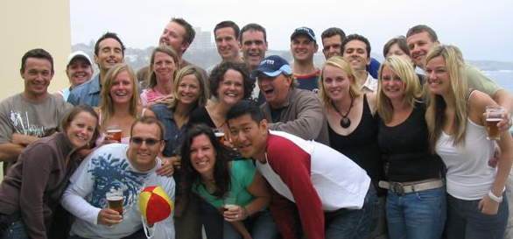

We are now only at the beginning of summer, and have already undertaken a couple of Beach Patrols (Somewhat uneventful thank god) and are quickly realizing that this year has passed us by all too quickly. We will be ending this year enjoying our time together and looking forward to the next year and what it has in store for us. 2004 has been a very exciting year, and we hope that next year sees us continue on the path we are currently travelling.

Hope all our friends around the world have had as good of a year as we have, and look forward to hearing from you all very soon. Remember, we have a spare bed here in Coogee, that may not be around that long, so if you feel that its time for a trip to Sydney, get on that plane and stop by to see us! We have been here almost a year now, and as you have probably learned to expect, we probably won’t be here forever, so don’t go putting that trip off too long!
Love to all and hope to hear from you all very soon.

Merry Christmas and wishing you all the best in the New Year!

Tim and Samantha Ferguson

